Research and Community service
Alongside the learning and teaching, the University also engages in research and community service activities. In order to ensure the relevance of knowledge and technology transfer,the University Senate has approved a guide line and thematic areas of for research and community service undertakings.
Research Thematic Areas of ASU
1. Information and Communication Technology
2. Construction Industry and Urban Enhancement
3. Water, Sanitation and Sustainable Energy
4. Livestock Production, Productivity and Animal Health
5. Crop Production, Protection and Productivity Improvement
6. Natural resource Management, Biodiversity, Conservation and Tourism
7. Creativity, Innovation and Science for Sustainability
8. Business, Finance and Management
9. Socio-cultural and Socio-Economic Development
10. Governance, Legal System and Human Rights
11. Quality of Education
12. Poverty, Livelihood Diversification and Food Security

With respect to addressing the above issues AsU established links with Assosa town administration and other Regional Bureaus.Based on the demands, a number of research and community service have been undertaken. For instance,in this Academic year alone, 40 researches and community service proposals have been approved. The approved proposals are ongoing.The university has also organized and hosted five annual National research conferences and one International research conference so far around 150 research papers were presented on the conferences.
With regard to community service, trainings conducted to Assosa town Teachers, students, members of micro enterprises, civil servants, farmers and Agricultural development agents….etc. In addition, the University has opened a Legal aid center to help vulnerable people with free Legal consultancy service at Assosa, Bambasi and Gilgel Beles towns.The university has opened one research center in the campus and an other center at Bambasi town. The other Research and Community Service Centers will be opened in the near future. On top of these the university has a plan establish cultural center, community school from KG up to High school and referral hospital at Assosatown.
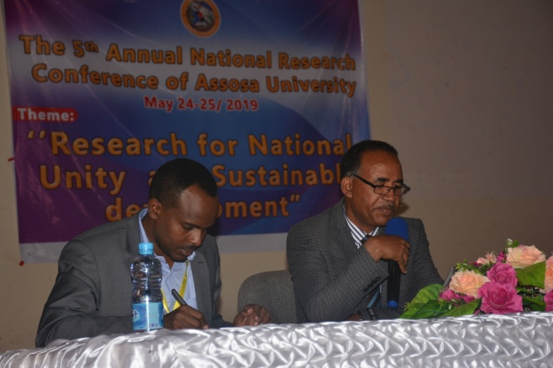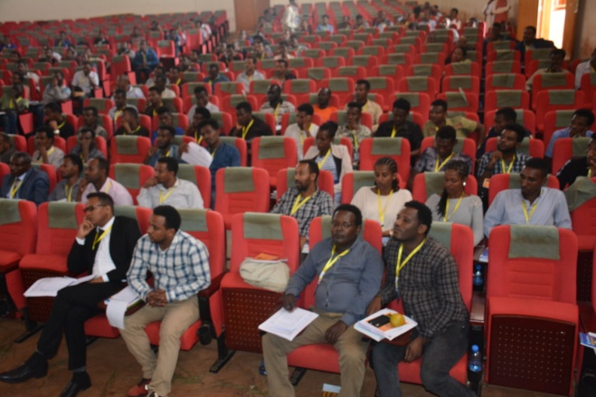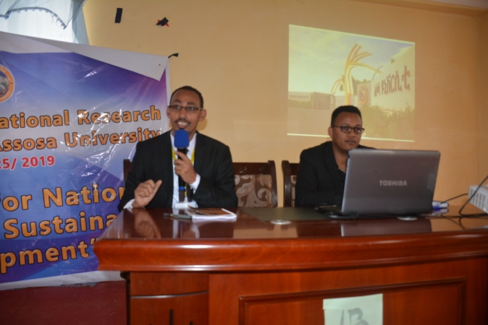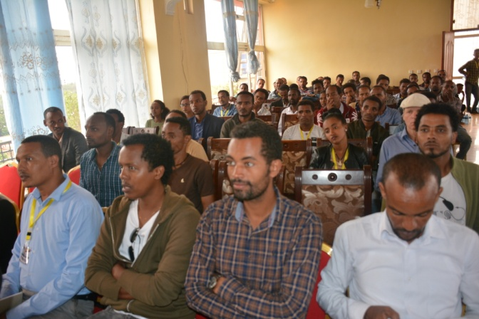TTTHETHE THETHE

T

T

